Ekram Bhuiyan 212914479

December 2017

**Novel Noise Suppression to enhance SIFT**

**1. Introduction**

**1.1 Motivation**

Images captured under conditions of very little brightness can severely threshold the amount of extractable information that would have otherwise been present. A common preprocessing step is to enhance contrast (i.e. boost gradient fields) in order to accentuate the existing features and improve detection probabilities. However, if samples are additionally noisy, a contrast boost may additionally amplify noise. As dim conditions characterize a poor SNR, noise amplification can potentially corrupt image samples. As such, the performance of algorithms such as Scale Invariant Feature Transform (SIFT) by increasing the number of false positives or decreasing the number of key points detected. SIFT in particular is affected against such test cases as low contrast key points are often thrown away and not recorded.

**1.2 Related Research**

The development of image matching by using a set of local key points can be traced back to the work of Moravec [7]. He defined the concept of "points of interest" as being distinct regions in images that can be used to find matching regions in consecutive image frames. The Moravec operator was further developed by C. Harris and M. Stephens [8] who made it more repeatable under small image variations and near edges. Schmid and Mohr [9] used Harris corners to show that invariant local features matching could be extended to the general image recognition problem. They used a rotationally invariant descriptor for the local image regions in order to allow feature matching under arbitrary orientation variations. Although it is rotational invariant, the Harris corner detector is however very sensitive to changes in image scale so it does not provide a good basis for matching images of different sizes. Lowe [1, 2, 3] overcome such problems by detecting the points of interest over the image and its scales through the location of the local extrema in a pyramidal Difference of Gaussians (DOG). The Lowe’s descriptor, which is based on selecting stable features in the scale space, is named the Scale Invariant Feature Transform (SIFT). Mikolajczyk and Schmid [10] experimentally compared the performances of several currently used local descriptors and they found that the SIFT descriptors to be the most effective, as they yielded the best matching results.

The improvement of feature descriptors against various classes of test cases characterizes a considerable portion of contributions to academia. A popular approach to do so is by some means of noise suppression. This is exemplified by Shokhan [4] and her work in applying locally tuned Gaussian filters in order to better reduce high frequency, noise corrupted components, and improve the performance of Uncanny Edge Detection.

A much more recent noise suppression algorithm is proposed by Dabov, Foi, Katkovnik, and Egiazarian [5] is Block Matching and 3D Filtering. Considered state of the art, it is noted by Hasan [6] that this algorithm does perform poorly given standard deviations greater than 30.

**1.3 Hypothesis**

Noise suppression through use of BM3D onto segmented image partitioned is proposed. Additionally, if the statistical standard deviation measures for each segment are greater than 30, a median filter will be applied in order to reduce the parameter a priori to application of BM3D. The image will then be contrast boosted and then SIFT will be applied. It will be shown that for poorly illuminated, noisy images, the noise suppression + contrast enhancement, as described, will improve the performance of SIFT. The performance metric by which we access SIFT is by the number of key points generated by the algorithm. We interpret the recovered key points as those that would have otherwise been thrown away.

**2 Approaches**

**2.1 Analysis**

**1. Sample Model**

Denote yi : yi = Image sample

xi : xi = Signal component

ni : ni = Noise component

*yi=**xi*+*ni*

*2. Noise Model*





3. Model for a given pixel

Denote L to be the bit width

Denote (j, k) to be 2D indices over which



-- Note that we apply a scheme where the image is reflected beyond the boundaries

4. Model for brightness and contrast

Denote ai as brightness (variable per pixel)

Denote bi as contrast (variable per pixel)





5. New model for signal yi



6. For our purposes, we wish to estimate



7. We wish to do so in order to increase the SNR of an image sample

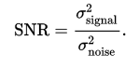

8. We choose BM3D as the applied mechanism about which we reduce noise. However, we note that BM3D is shown to significantly decrease (i.e. produce many artifacts) when variance is greater than 30. If this is the case, we apply a decision based median filter onto each sub image if the statistical parameter is shown to be greater than 30.

9. We now define a window that we will use for our median filtering

Denote the Window:

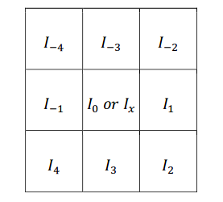

Where the above window can be analytically modeled as



10. We convolute the image about every pixel of the image in order. From the convolution, we derive the following vector s(x). Note that there are 8 values because the pixel in consideration is not included.





11. If the current pixel is greater that the sum of the surrounding components, we make it the median of the components around it. Otherwise, we leave it as is and continue the convolution.

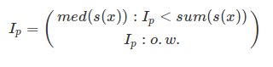

**2.1 Implementation**

The following algorithm written in pseudocode models the implementation applied in order to generate a solution for the problem which is mathematically modelled above,

**Proposed Algorithm**

Input: An image sample yi

Output: Number of key points, entropy of the image before being noise suppressed, entropy after being noise suppressed.

1. Divide Image into k sub images – where k is a tunable hyper parameter.

2. Calculate the standard deviation for each sub image.

3. If the standard deviation is greater than 30, apply the median filter over every pixel. Consequent to the filtering, apply BM3D noise suppression. If the standard deviation is less than 30, apply BM3D noise suppression.

4. Perform a histogram based contrast boost.

5. Apply SIFT to generate an image of key points, and the number of key points.

**3 Empirical Evaluations**

**3.1 Empirical Protocol**

For every image experimented upon, we will test SIFT against an image prior to be noise suppressed, and then afterwards. Through this, we will be able to compare the two upon the basis of how many key points were generated. We will additionally determine the entropy of the original image and the entropy of the image after being noise suppressed (but before the contrast enhancement step). Entropy in this case is useful as it characterizes the inherent randomness of an image – often due to noise. By reducing entropy, we in turn limit noise variance, and thus boost SNR. This boost in SNR characterizes robustness against noise amplification in the contrast enhancement step.

**3.2 Experimental Results**

For this report, we will show the results of the preprocessing step as carried out upon a poorly illuminated, noisy image shown in figure (a), and the output a priori to being applied against SIFT, as shown in figure (b).

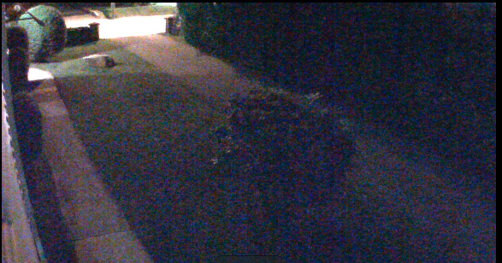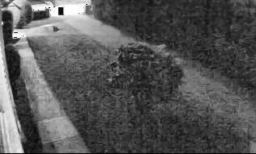

**Figure a** (Entropy = 6.58696) **Figure b** (Entropy = 6.38908)

We next carry out the key point generation by use of the SIFT algorithm. The results that come about from passing each image (i.e. Figure a and Figure b) are enumerated about the table below.

Figure c – Results Table

|  |  |
| --- | --- |
| Image | Key points |
| Figure a | 106 |
| Figure b | 114 |

As expected, more key points are generated for the Figure b. We interpret the results of having recorded more key points as being able to recover those key points which would have otherwise been thrown away by SIFT as they would have been drawn from low contrast regions about the image.

**4. Conclusion**

Noise suppression is indeed an important preprocessing step that is done to ensure that the maximum amount of information can be recovered from a given image sample. The proposed algorithm involves use of noise suppression step to augment and improve Scale Invariant Feature Transform. Due to time constraints, only a few measures analytical measures were undertaken in order to see how original SIFT was improved. Additionally, due to issues working with openCV, we were unable to draw key points onto images, and instead, just counted key points from a text file. Having visual examples would have indeed made the live demo much more appealing. In the future, additional tests such as ones where we see if the augmented SIFT output images perform better with recognition tasks will be undertaken.

**References**

[1] David G. Lowe. : Object recognition from local scale-invariant features, International Conference on Computer Vision, Corfu, Greece (September 1999), pp. 1150-1157.

[2] David G. Lowe. : Local feature view clustering for 3D object recognition, IEEE

Conference on Computer Vision and Pattern Recognition, Kauai, Hawaii (December 2001), pp. 682-688.

[3] David G. Lowe. : Distinctive image features from scale-invariant key-points, International Journal of Computer Vision, 60, 2 (2004), pp. 91-110.

[4] Shokhan M.N : AN EFFICIENT APPROACH FOR IMPROVING CANNY EDGE DETECTION ALGORITHM, Al-Anbar Univ, pp. 1-7

[5] Alhwarin et all: Improved SIFT-Features Matching for Object Recognition, University of Bremen, pp. 1 -2

[6] Mohammad Mahedi Hasan:Adaptive Edge Guided Block matching and 3d Filtering (BM3D) Image denosing algorithm, Western University, pp. 1-121

[7] H. P. Moravec. : Towards Automatic Visual Obstacle Avoidance, Proc. 5th

International Joint Conference on Artificial Intelligence, pp. 584, 1977.

[8] C. Harris and M. Stephens. : A Combined Corner and Edge Detector. Proc. Alvey Vision Conf., Univ. Manchester, pp. 147-151, 1988.

[9] C. Schmid, R. Mohr. : Local Greyvalue Invariants for Image Retrieval, IEEE

Transactions on Pattern Analysis and Machine Intelligence 1997.

[10] K. Mikolajczyk and C. Schmid. : A Performance Evaluation of Local Descriptors, IEEE TRANSACTIONS ON PATTERN ANALYSIS AND MACHINE INTELLIGENCE, VOL. 27, NO. 10, OCTOBER 2005.